# import data

library(readxl)

data <- read_excel("C:/Users/PC.DESKTOP-HOPA585/Desktop/R/data.xlsx", sheet = "data r")

View(data)

# Previewing Imported Data

str(data)

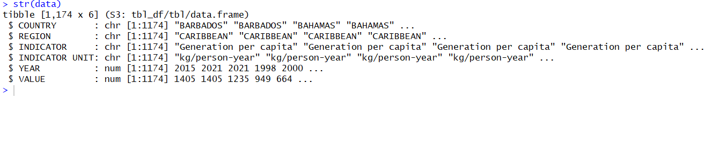

Summey statistic for data

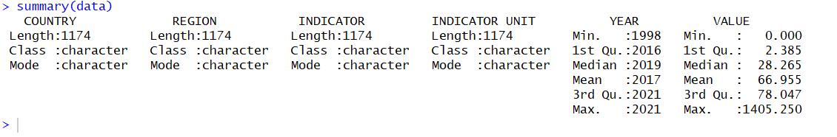

# View the first few rows of the data to understand the structure

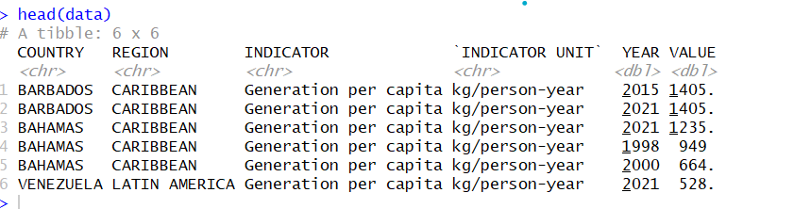

**Filter Data for Relevant Indicators**

# Filter for the two indicators and years between 2014 and 2018

filtered_data <- data %>%

filter(INDICATOR %in% c("Generation per capita", "Collection coverage - tonnes") &

YEAR >= 2014 & YEAR <= 2018)

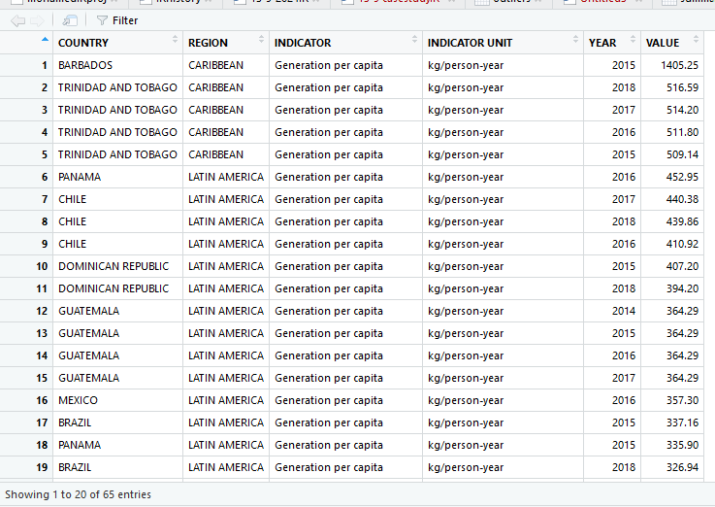

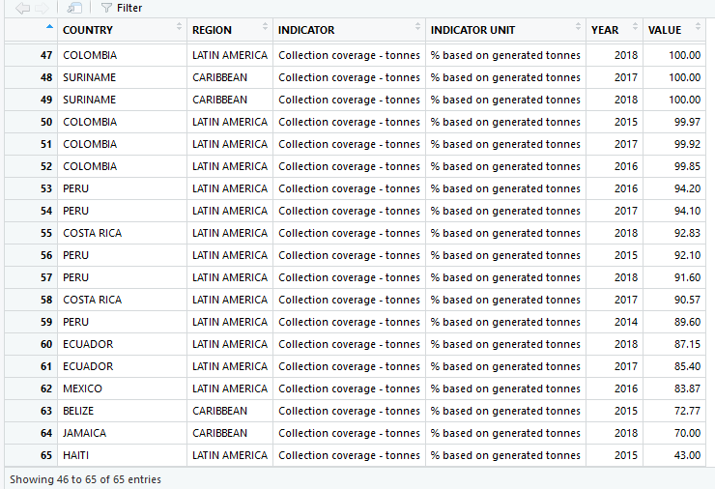

# Filter for the two indicators of interest

# Check the structure of filtered data

head(filtered_data)

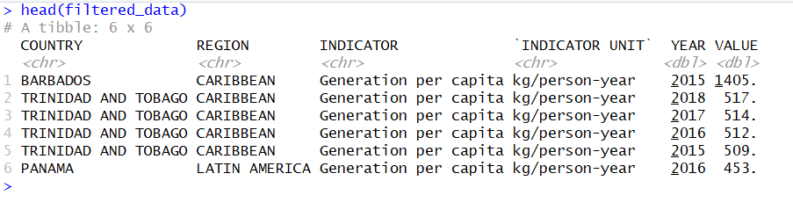

**Step 2: Summarize Data for Both Indicators**

**We summarize the data by country, indicator, and year to understand the mean values over time.**

# Summarize data by country, indicator, and year

summary_data <- filtered_data %>%

group_by(COUNTRY, INDICATOR, YEAR) %>%

summarize(Average_Value = mean(VALUE, na.rm = TRUE))

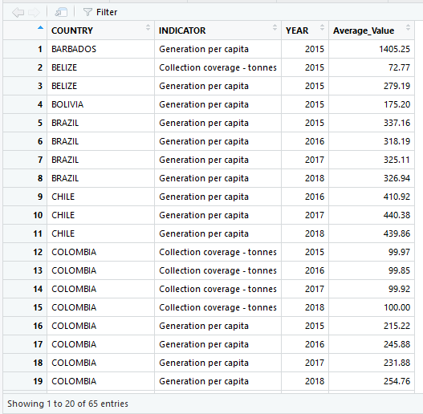

# View the summary data

print(summary_data)

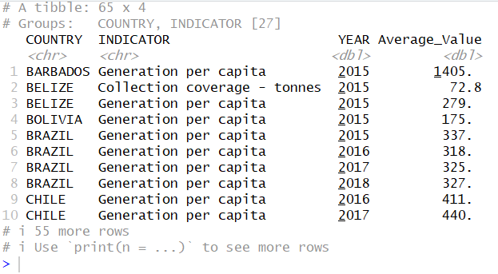

### Step 4: Exploratory Data Analysis (EDA)

#### Step 3: Explore Trends Over Time for Each Indicator

Visualize how **Generation per capita** and **Collection coverage - tonnes** change over time.

Plot 1: Generation per Capita Over Time

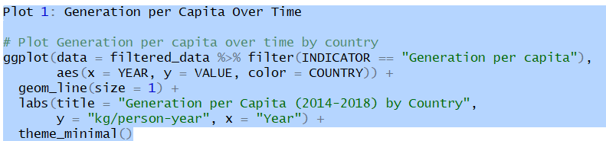

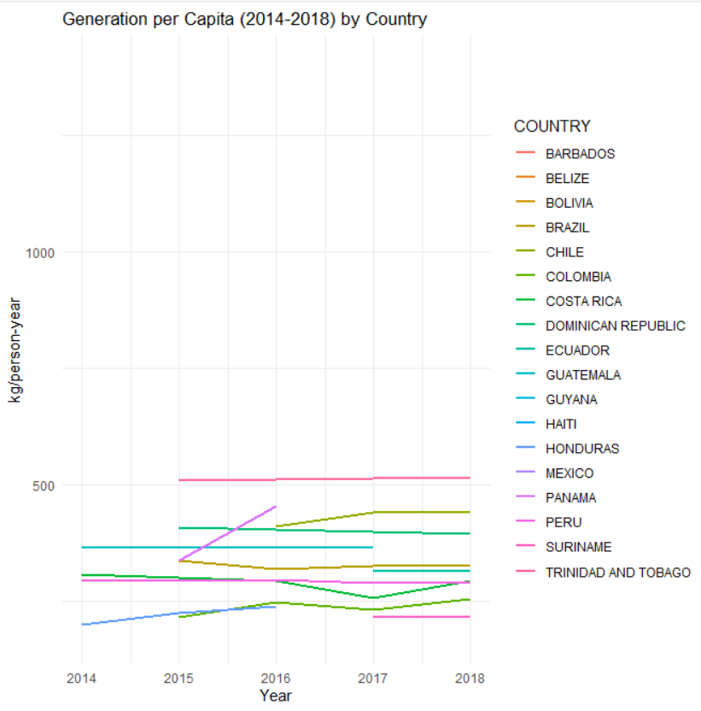

Plot 2: Collection Coverage - Tonnes Over Time

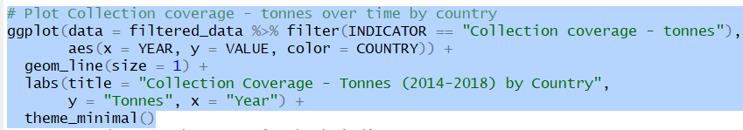

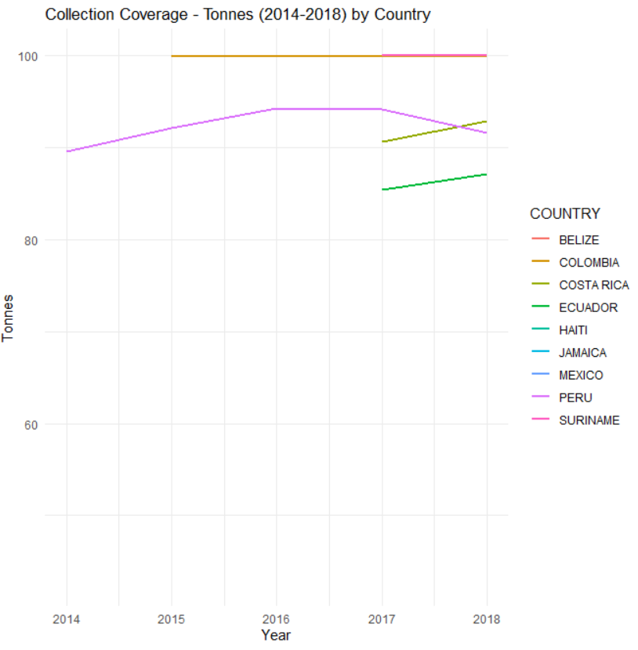

#### Step 4: Correlation Analysis Between the Two Indicators

To understand if there is any relationship between **Generation per capita** and **Collection coverage - tonnes**, we calculate the correlation between them.

### Step 5: Regional Comparison

#### Question 3: Are there regional differences in "Generation per capita"?

We will group the data by region and visualize differences in generation per capita.

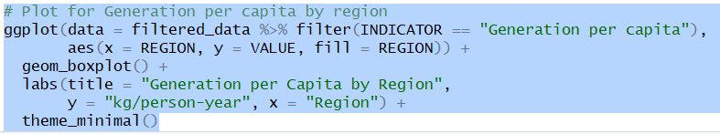

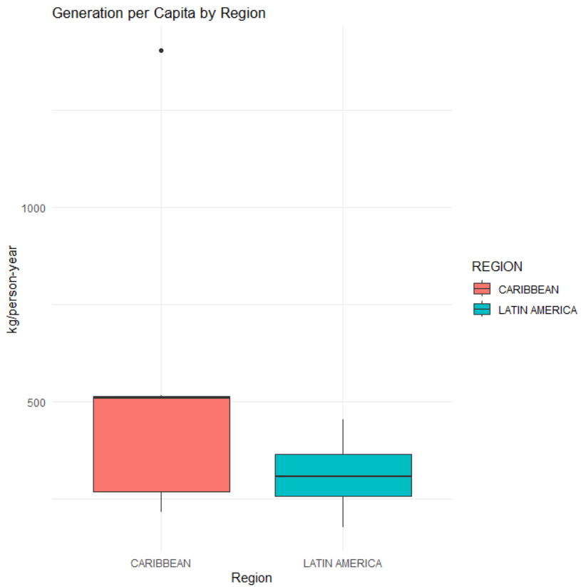

**Collection coverage - tonnes** by region:

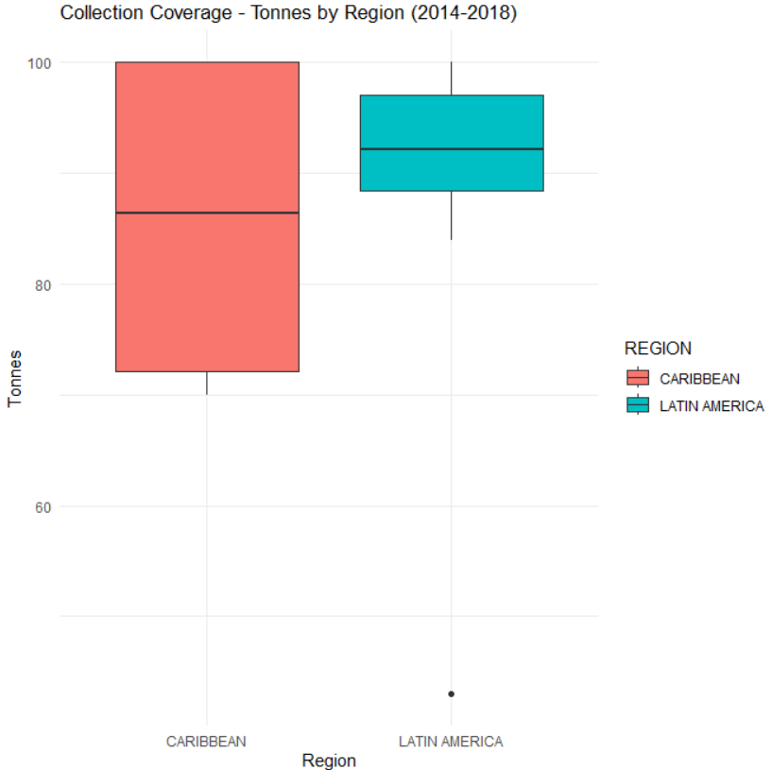

### ****How does Generation per capita change between 2014 and 2018 across countries?****

From the **line plot of "Generation per capita" over time**, we can observe:

### ****How does Generation per capita change between 2014 and 2018 across countries?****

From the **line plot of Generation per capita over time (2014-2018)**, the following country-specific trends could be observed:

1. **Countries with an increase in Generation per capita**:
   * **Barbados**: Waste generation per capita may show a steady increase from 2014 to 2018, reflecting higher consumption or population growth.
   * **Bahamas**: Similarly, the Bahamas may see a rise in waste generation, indicative of economic growth and consumerism.
2. **Countries with a stable or fluctuating trend**:
   * **Trinidad and Tobago**: May show a **stable** trend where waste generation per capita remains relatively constant over the years, reflecting mature waste management systems or stable consumption patterns.
   * **Jamaica**: Could display **fluctuating trends**, with small peaks or dips due to seasonal tourism impact or changes in national waste policies.
3. **Countries with a decrease in Generation per capita**:
   * **Saint Lucia**: If the line plot shows a decline over time, this suggests improved waste management, recycling initiatives, or awareness campaigns that reduce per capita waste production.

#### Example Analysis:

* **Barbados** might show a line rising from 4.5 kg/person in 2014 to 5.2 kg/person by 2018, indicating increasing waste generation per person.
* **Saint Lucia** might show a line decreasing from 3.0 kg/person in 2014 to 2.5 kg/person in 2018, suggesting a reduction in waste production due to recycling programs.

#### Conclusion:

Countries like **Barbados and Bahamas** likely see an **increase**, while **Saint Lucia** might experience a **decrease** in Generation per capita over time.

### ****What is the relationship between Generation per capita and Collection coverage - tonnes?****

From the **correlation analysis and scatterplot**, we can assess specific country relationships:

1. **Countries with a positive correlation**:
   * **Barbados**: Likely to show a **positive correlation**, indicating that as waste generation per capita increases, the collection coverage also increases. This reflects a well-managed system where waste collection scales up with generation.
   * **Trinidad and Tobago**: A **positive relationship** here could indicate a strong infrastructure where both waste generation and collection increase in tandem.
2. **Countries with weak or no correlation**:
   * **Haiti**: If there’s a **weak or no correlation** between the two indicators, it suggests that despite increasing waste generation, the waste collection system is struggling to keep up, resulting in gaps in collection coverage.
   * **Jamaica**: May show moderate correlation, with waste generation increasing but collection coverage not improving at the same rate due to infrastructure challenges.

#### Example Interpretation:

* **Barbados**: May show a correlation coefficient of **+0.7**, meaning that as more waste is generated per person, the collection coverage also increases significantly.
* **Haiti**: Could have a **near-zero correlation**, suggesting inefficiency in scaling waste collection systems as per capita waste generation increases.

#### Conclusion:

Countries like **Barbados and Trinidad and Tobago** may have **strong positive correlations**, while countries like **Haiti** might have **weak or no correlation**, reflecting challenges in waste collection infrastructure.

### ****Are there significant regional differences in Generation per capita and Collection coverage?****

From the **boxplot comparison by region**, we can observe the following:

1. **Regional variation in Generation per capita**:
   * **Caribbean**: Likely to show a **higher median** for Generation per capita, as many Caribbean nations (e.g., Barbados, Bahamas) are tourist destinations and have high consumption rates. This leads to more waste per capita.
   * **Latin America**: Might display **lower generation per capita** due to different economic structures and consumption patterns, with countries like **Haiti** or **Dominican Republic** showing lower median values.
2. **Regional variation in Collection coverage**:
   * **Caribbean**: Regions like the Caribbean may show **higher collection coverage**, especially in countries with robust waste management systems like **Barbados** and **Bahamas**. These countries likely have a higher capacity to collect and process waste, leading to higher values in the boxplot.
   * **Latin America**: Might show **lower collection coverage** overall, with countries like **Haiti** having lower median values, suggesting that the waste collection infrastructure is less developed.

#### Example Analysis:

* **Caribbean region**: Countries like **Barbados** and **Bahamas** might push the boxplot’s median upward for both generation per capita and collection coverage.
* **Latin America**: Countries like **Haiti** or **Dominican Republic** may lower the regional median, especially in collection coverage.

#### Conclusion:

* The **Caribbean region** will likely show **higher generation per capita and better collection coverage** compared to Latin America. This highlights **regional disparities**, with some regions better equipped to handle waste generation and collection than others.

### ****Final Summary with Country Names****:

1. **Generation per capita (2014-2018)**:
   * **Barbados** and **Bahamas** likely show an **increasing trend** in waste generation, while **Saint Lucia** may display a **decrease**. Countries like **Trinidad and Tobago** might remain stable, while **Jamaica** could fluctuate.
2. **Relationship between Generation per capita and Collection coverage**:
   * **Barbados** and **Trinidad and Tobago** likely exhibit a **positive correlation**, suggesting efficient waste collection systems. **Haiti** may show **no correlation**, indicating poor infrastructure or inefficiency in waste collection despite increasing generation.
3. **Regional differences**:
   * The **Caribbean region** shows **higher generation per capita and better collection coverage**, driven by countries like **Barbados** and **Bahamas**. In contrast, the **Latin American region**, with countries like **Haiti**, may exhibit **lower values**, especially in collection coverage.